SOFTWARE

REQUIREMENT

SPECIFICATION

**INTRODUCTION**

The main aim of this application is that the user can play media files using this program.

Also sometimes the user has to download some codec softwares to play certain type of music files on heavy media players, which can be avoided using this player.

User can play songs of the following format:

**Audio Files-**

1. .aif Audio Interchange File Format
2. .iff Interchange File Format
3. .m3u Media Playlist File
4. .m4a MPEG-4 Audio File
5. .mid MIDI File
6. .mp3 MP3 Audio File
7. .mpa MPEG-2 Audio File
8. .ra Real Audio File
9. .wav WAVE Audio File
10. .wma Windows Media Audio File

**Video Files-**

1. .3g2 3GPP2 Multimedia File
2. .3gp 3GPP Multimedia File
3. .asf Advanced Systems Format File
4. .asx Microsoft ASF Redirector File
5. .avi Audio Video Interleave File
6. .flv Flash Video File
7. .mov Apple QuickTime Movie
8. .mp4 MPEG-4 Video File
9. .mpg MPEG Video File
10. .rm Real Media File
11. .srt SubRip Subtitle File
12. .swf Shockwave Flash Movie
13. .vob DVD Video Object File
14. .wmv Windows Media Video File

**Image Files-**

1. .obj Wavefront 3D Object File
2. .bmp Bitmap Image File
3. .dds DirectDraw Surface
4. .dng Digital Negative Image File
5. .gif Graphical Interchange Format File
6. .jpg JPEG Image
7. .png Portable Network Graphic
8. .psd Adobe Photoshop Document
9. .tga Targa Graphic
10. .thm Thumbnail Image File
11. .tif Tagged Image File
12. .ai Adobe Illustrator File
13. .eps Encapsulated PostScript File
14. .ps PostScript File

**Features:**

* The user can organize particular group of songs into playlist for future reference.
* Users can add or remove the music files to the playlist by choosing the corresponding option.
* The playlist is saved as a text document as per the location given by the user.
* The number of songs played at a time is limited to one.

**Basic Functionalities:**

* Play song/video
* Pause song/video
* Stop song/video
* Forward song/video
* Rewind song/video
* Create Playlist
* Update Playlist (add/delete)
* Select from playlist
* Choose the next/previous song/video from playlist
* Adjust the volume
* Mute the volume
* Navigation using slider
* View images
* Stop viewing images

**TECHNICAL DETAILS**

**Software used for developing the application:**

* OS Windows 7
* Tool NetBeans IDE 7.1.2
* Language JAVA
* Technology vlcj class
* Platform jdk 1.7.0_04

**Minimum Hardware and Software Requirements at Client level:**

**HARDWARE-**

* Processor-Intel Pentium 4
* RAM-256 MB
* Hard Disk Space-40.0 kB
* Speakers

**SOFTWARE-**

* Windows 7 / Windows XP
* Jdk 1.7.0_04
* NetBeans IDE 7.1.2
* vlcj.jar files
* Vlc media player 2.0.1

**OBJECTIVE**

The Media Player enables an end user to play music files saved on his/her computer.

The main objective of this application is that the user can play media files using this program.

Also sometimes the user has to download some codec softwares to play certain type of music files on heavy media players, which can be avoided using this player.

This is a desktop application which can be used on other systems by copying the necessary files.

The application will help to play music or video and view images of the commonly used format i.e. .mp3, .avi, .jpg respectively as well as several other formats.

**E-R DIAGRAM**

**USER**

Is Operating On

Has

**LOCATION**

**MEDIA**

Is Type

**PHOTO**

**MUSIC**

**VIDEO**

**FLOW DIAGRAM**

**Help**

**Playlist**

**Media**

No

No

No

No

No

Yes

Yes

No

No

**Create Playlist**

**Update Playlist**

**Open Playlist**

**Exit**

**Open File**

Yes

Yes

Yes

Yes

No

**Enter name & Choose Location**

**Choose Media File**

**Choose Playlist**

**Choose Playlist**

Yes

Yes

**Choose Media File**

**Do you want to add another file?**

No

**LIMITATIONS**

1. No visualizations
2. No full screen facility
3. No advanced functionalities present

**SNAPSHOTS**

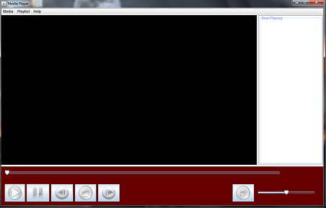

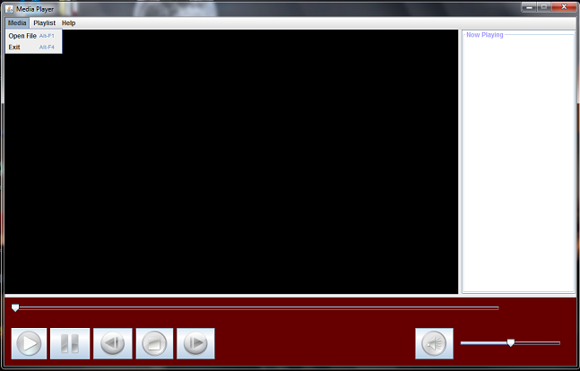

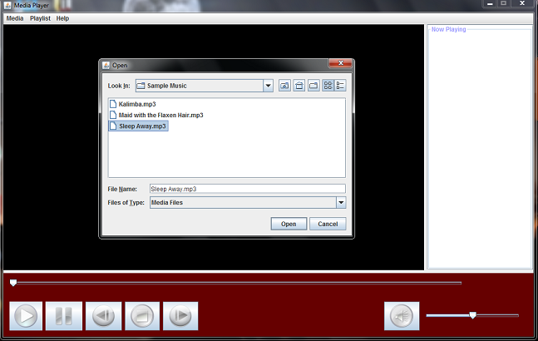



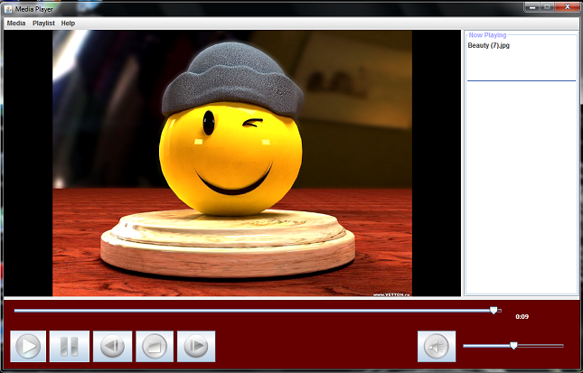

**BIBLIOGRAPHY**

* Java Tutorials available on the internet.
* The Complete Reference Java 2 by HERBET SCHILDT.